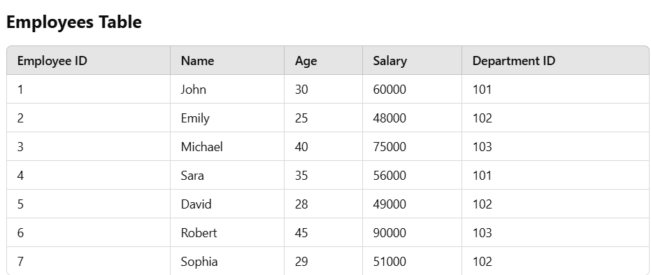

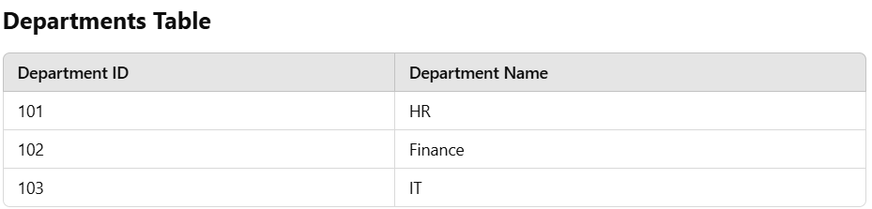

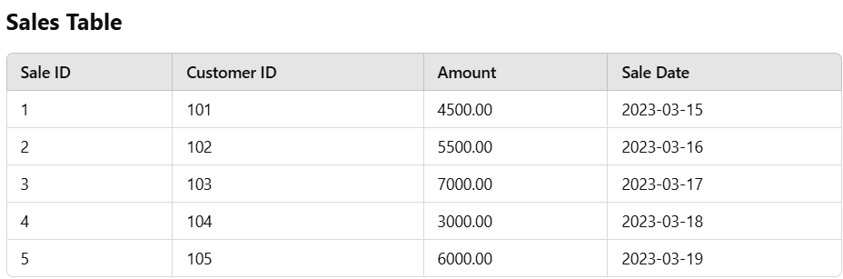

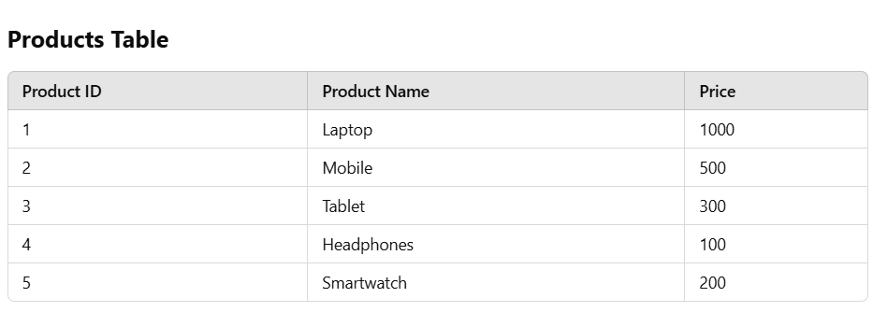

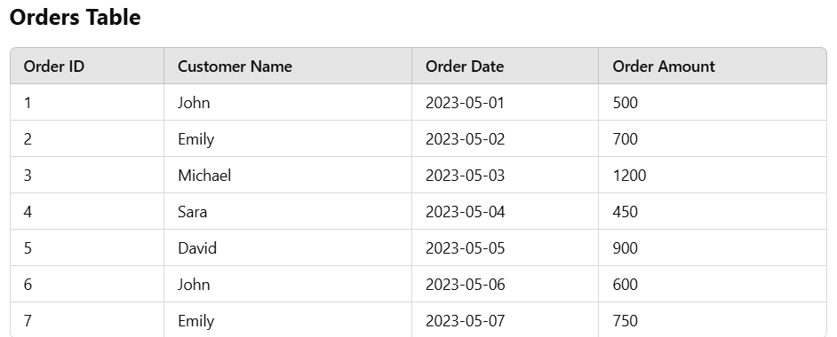

### **Questions**

1. Retrieve all employees whose salary is greater than **60000**.
2. Calculate the total sales amount for each customer from the **sales** table.
3. Retrieve the names and salaries of all employees working in the **Finance** department.
4. Find the total sales amount made on **2023-03-17** from the **sales** table.
5. Get the names of customers who have placed an order of more than **600** from the **orders** table.